Sport Mode Fixed Dedicated RTT – GCEA1.3

Functional Description

The purpose of the Sport_Mode_RTT is to inform the driver that they are in transmission based Sport Mode.

The Sport_Mode_RTT correlates the PtDrvMde_D_Stat signal and the Operational_Mode to illuminate or extinguish the Sport Mode RTT.

2020 CD391N is deleting the paddle shifters on the 1.5L engine. This requires that this STSS be added to the program, but since STSS “Sport Mode Fixed_Dedicated RTT - CD391 with V6 Engine Specific - CGEA1.3_v1.0.doc” is already used by the 2.7L V6, we are adding CCD_Cfg to this STSS to keep the 2 STSS’s mutually exclusive. In other words, on the 1.5L the PCM will send PtDrvMde_D_Stat to illuminate the Sport Mode RTT, and on the 2.7L V6, the VDM will send CcdMsgTxt_D_RqDsply to illuminate the Sport Mode RTT. The cluster shall use CCD_Cfg to determine which CAN signal to use.

The Sport_Mode_RTT shall provide an iconic representation that will illuminate or extinguish to inform the driver whether or not they are in transmission based Sport mode on an automatic transmission vehicle.

This section describes the RTT function and sets a flag that is used by the Message Center display (See Message Center Section for details of Message Display Algorithm).

Interfaces

Interface Context Diagram (I/O Block Diagram)
Figure 1. Sport Mode RTT Indication
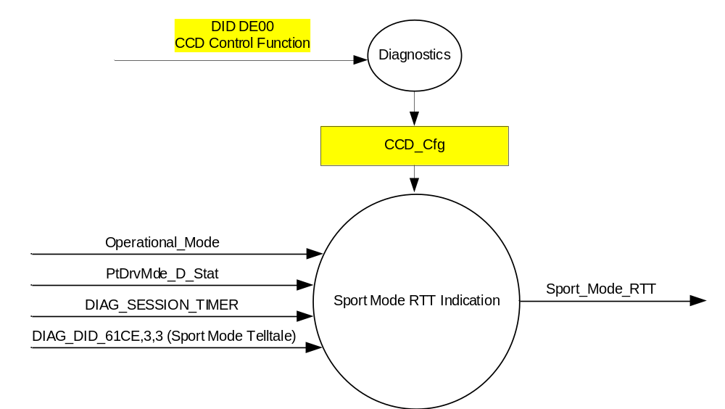

Inputs
      - INTERNAL:
            - CCD_Cfg (Also defined in “CCD Control Function w Adaptive Drive - CGEA1.3” STSS)
            - DIAG_SESSION_TIMER
            - Operational_Mode
      - DIAG_DID_61CE,3,3 (Sport Mode Telltale)
      - MUX message on the CAN Bus from PCM/TCM

- PtDrvMde_D_Stat Signal
Signal Name | Size  (bits) | Detail | Units | Res. | Offset | State  Encoded | Min. | Max.
PtDrvMde_D_Stat | 3 |  | SED | 1 | 0 |  | 0  (0x0) | F  (0xF)
 |  | Normal |  |  |  | 0x0
 |  | Sport |  |  |  | 0x1
 |  | SnowWet |  |  |  | 0x2
 |  | TowHaulGradeAssist |  |  |  | 0x3
 |  | NotUsed1 |  |  |  | 0x4
 |  | NotUsed2 |  |  |  | 0x5
 |  | NotUsed3 |  |  |  | 0x6
 |  | NotUsed4 |  |  |  | 0x7
 |  | NotUsed5 |  |  |  | 0x8
 |  | NotUsed6 |  |  |  | 0x9
 |  | NotUsed7 |  |  |  | 0xA
 |  | NotUsed8 |  |  |  | 0xB
 |  | NotUsed9 |  |  |  | 0xC
 |  | NotUsed10 |  |  |  | 0xD
 |  | NotUsed11 |  |  |  | 0xE
 |  | Faulty |  |  |  | 0xF

Outputs
Sport_Mode_RTT, which is used to control the state of the Reconfigurable Telltale

Function/Performance

Operational Modes

Mode | Differentiating Vehicle Conditions
Sleep Mode | Sport_Mode_RTT = Inactive
Limited Mode | Sport_Mode_RTT = Inactive
Normal Mode | Sport_Mode_RTT = Active/Inactive
Crank Mode | Sport_Mode_RTT = Active/Inactive

The above table references the setting of the RTT flag as per this section. However, the actual RTT display operational modes are displayed in the Message Center section of this SPSS.

Voltage Levels

Refer to the Cluster Features table located in the Operational Modes and Voltage Range Strategies Section in this SPSS

Human-Machine Interface

Visual

Indicator Graphics / Display Format

SPORT
MODE

Or 

For actual symbol definition see the symbol definition database in the 03-0685 ARL requirement.

Indicator Color Coordinates

Amber - Reference SDS IL-0017/IS-0379

Indicator Characteristics

Pixel Display in Message Center Display – SPORT MODE RTT

Audio

None

Switch Control Logic

Not Applicable

System Accuracy

The state of the Sport_Mode_RTT shall change within 100msec of a state change as indicated in the state matrix reference 1.3.5.1 Subsystem Algorithm Flowchart/ State Diagram

Operation: Performance and Functional

Subsystem Algorithm Flowchart / State Diagram

- State Matrix for Sport_Mode_RTT Flag
Operational_Mode | CCD_Config | DIAG_SESSION_TIMER | DIAG_DID_61CE,3,3 | PtDrvMde_D_Stat  Signal | Sport_Mode_RTT
Normal or Crank | Disabled (0x0) | Not Active | X | Sport (0x1) | Active
Normal | Disabled (0x0) | X | Not Received | Missing as per section 1.4.1 | Inactive
Normal | Disabled (0x0) | Active | Not Received | Sport (0x1) | Active
Normal | Disabled (0x0) | Active | ON (0x1) | X | Active
All Other Cases with CCD_Config = Disabled (0x0) |  |  |  |  | Inactive
X = Don’t Care
Not Received = The state when a DIAG_SESSION_TIMER is active and the DID has not been received.

Operation Description (supports algorithm flowchart /state diagram)

- Sport_Mode_RTT shall reflect signal state within 100mS of receipt of PtDrvMde_D_Stat Signal.
- The actual RTT display operational modes are displayed in the Message Center Section of this SPSS.
- PtDrvMde_D_Stat signal used in this STSS replaces TrnShifMde_D_RqDrv signal. If a particular program does not support PtDrvMde_D_Stat signal and uses TrnShifMde_D_RqDrv signal then advise DI Core Group as a program unique STSS will need to be generated.
- If a vehicle is equipped with transmission based Sport Mode feature and Tow/Haul feature the Sport Mode RTT and Tow Haul RTT shall be implemented on the same space as they are mutually exclusive (never on at the same time).

Function Safety Classification (EMC)

Class B

Memory Storage

Parameter Name | Description | Value at  Battery Connect | Value at  Module Wake-up
Sport_Mode_RTT | Used to control the state of the RTT | Inactive (0x0) | Inactive (0x0)
PtDrvMde_D_Stat signal | CAN signal sent from the TCM | Normal (0x0) | Normal (0x0)
CCD_Cfg | Configures cluster to allow CCD. Set to Disabled at Cluster Supplier Manufacturing Plant. (Defined in “CCD Control Function w Adaptive Drive - CGEA1.3” STSS) | Use Stored Value | Use Stored Value
DIAG_DID_61CE 3,3 (Sport Mode Telltale) | Warning Lamp "B" Status byte 3 bit 3 (Sport Mode Telltale) | 0 (0x0) | 0 (0x0)
Operational_Mode | 4 state indicator for cluster operational mode | Limited | Limited or Normal or Crank

Parameter Name | Description | Value at Battery Connect | Value at Module Wake-up
DIAG_SESSION_TIMER | Timer used to time-out a diagnostic session | Not Active | Not Active

Prove Out

No

Reconfigurable Telltale

Yes

Message Center Msg

See Message Center Section for displaying RTT based upon state of RTT flag

Error Handling

Missing Message Strategy
PtDrvMde_D_Stat is NOT a standard signal on all powertrains. Therefore, the cluster shall never log a missing message DTC for that signal.

DTCs states and history will be determined as per the Diagnostics section of this SPSS.

Diagnostics

Self Test

None

Engineering Test Mode

Reference section “Dealer / Engineering Test Mode (ETM)”

Part II Performance

Supported Diagnostic DIDs (Service $22 and $2F)
Number | DID / CommonID Name | DID Type
61CE | Warning Lamp "B" Status byte 3 bit 3  (Sport Mode Telltale) | Bit Mapped

Supported Diagnostic Trouble Codes (DTCs)
DTC | Description
C10000 | Lost communication with ECM/PCM

DID DExx:
Block  Num | Block Description | Size (bits) | Type | Byte(s) | Bits | State: Description | "0" | "1" | Default | Comments/Information
PACKETED BLOCKS
$00 | Option Content (B&A) | 1 | 1 | * | * | CCD Control Function | Disabled | Enabled | Disabled | Disabled means the VDM is not present in the vehicle. Enable whenever the VDM is present in the vehicle.  (This is a duplicate from “CCD Control Function w Adaptive Drive - CGEA1.3” STSS.
 | *Byte and bit location to be identified in Part II Specification for this cluster

Reference Specification

AN-0008 BRAKE CONTROL ON/OFF SWITCH AND LIGHTS DEFINITION
AN-0263 BRAKE CONTROL MODES OF OPERATION

IS-0001 WARNINGS/INDICATORS/DISPLAYS PROVEOUT
IS-0046 INSTRUMENTATION MATERIAL RESISTANCE TO CLEANING
IS-0052 OPERATING VOLTAGES - FUNCTIONAL/PERFORMANCE
IS-0069 FUNCTIONAL IMPORTANCE CLASS
IS-0324 WINDSHIELD & OTHER REFLECTIONS
IS-0327 WARNING INDICATOR EVALUATION
IS-0329 FLICKERING OF LAMPS
IS-0379 NORTH AMERICAN WARNINGS AND INDICATORS STRATEGY

IL-0017 TELLTALE AND INTERIOR ILLUMINATION COLOR
IL-0021 CRAFTSMANSHIP - DISPLAYS
IL-0023 CLARITY/LEGIBILITY/READABILITY
IL-0025 INTERIOR ILLUMINATION INTENSITY
IL -0027 VISUAL CONTRAST
IL -0043 OPERATIONAL ENVIRONMENT FUNCTIONALITY
IL -0045 COLOR
IL -0047 TELLTALE; INDICATOR AND DISPLAY LIGHT INTENSITY
IL -0048 ILLUMINATION ACCEPTABILITY

03-0661 PLACEMENT: CONTROL AND DISPLAY LOCATIONS
03-0662 PLACEMENT: LOGICAL GROUPING FUNCTION AND USAGE
03-0664 PLACEMENT: DOWN VISION TO COMPONENTS WITH HIGH VISUAL DEMAND
03-0665 PLACEMENT: EXPECTED LOCATIONS OF CONTROLS AND DISPLAYS VDS
03-0670 INTERIOR VISIBILITY
03-0671 INTERIOR VISIBILITY: REFLECTIONS FROM COMPONENTS & SURFACES
03-0672 INTERIOR VISIBILITY: REFLECTIONS IN DISPLAYS
03-0673 INTERIOR VISIBILITY: VISUAL OBSCURATIONS
03-0674 INTERIOR VISIBILITY: ILLUMINATION CONTROLS / DISPLAYS
03-0675 INTERIOR VISIBILITY: VEILING GLARE
03-0677 INTERIOR VISIBILITY: SUNLIGHT WASHOUT
03-0681 IDENTIFICATION: CHARACTER AND SYMBOL SIZE
03-0682 IDENTIFICATION: LEGIBILITY
03-0685 IDENTIFICATION: SYMBOLS, ABBREV FOR CONTROL
03-0721 LOGIC OF OPERATION: OPERATIONAL STEREOTYPES
03-0722 LOGIC OF OPERATION: INTERPRETATION
03-0723 LOGIC OF OPERATION: USE OF SYSTEMS WITH VISUAL DISPLAYS

Revision History

SPSS Module Revision History

Revision Level | Name | Change Description | Date
1.0 | J.Blatchford | Initial Release | 11/12/12
2.0 | S. Watkins | 2020 CD391N is deleting the paddle shifters on the 1.5L engine. This requires that this STSS be added to the program, but since STSS “Sport Mode Fixed_Dedicated RTT - CD391 with V6 Engine Specific - CGEA1.3_v1.0.doc” is already used by the 2.7L V6, we are adding CCD_Cfg to this STSS to keep the 2 STSS’s mutually exclusive. In other words, on the 1.5L the PCM will send PtDrvMde_D_Stat to illuminate the Sport Mode RTT, and on the 2.7L V6, the VDM will send CcdMsgTxt_D_RqDsply to illuminate the Sport Mode RTT. The cluster shall use CCD_Cfg to determine which CAN signal to use.  DI CC Offline approval date of 1/17/2018.  Changes highlighted in yellow:  - Section 1.1 – Updated description  - Section 1.2.1 and 1.2.2 – Added CCD_Cfg  - Sxection 1.3.5.1 – Table 1.1 – Added column for CCD_Cfg to show that this STSS is only applicable when CCD_Cfg is Disabled. Also deleted row for “missing” signal since PtDrvMde_D_Stat is not standard.  - Section 1.3.5.4 – Added CCD_Cfg  - Section 1.4.1 – Modified missing message strategy  - Section 1.5.3 – Deleted DTC and added DE00 CCD_Cfg. | 1/17/2018

